**Task 1**

**1& 2) Database creation and inserting sample data**

**StudentInfo**

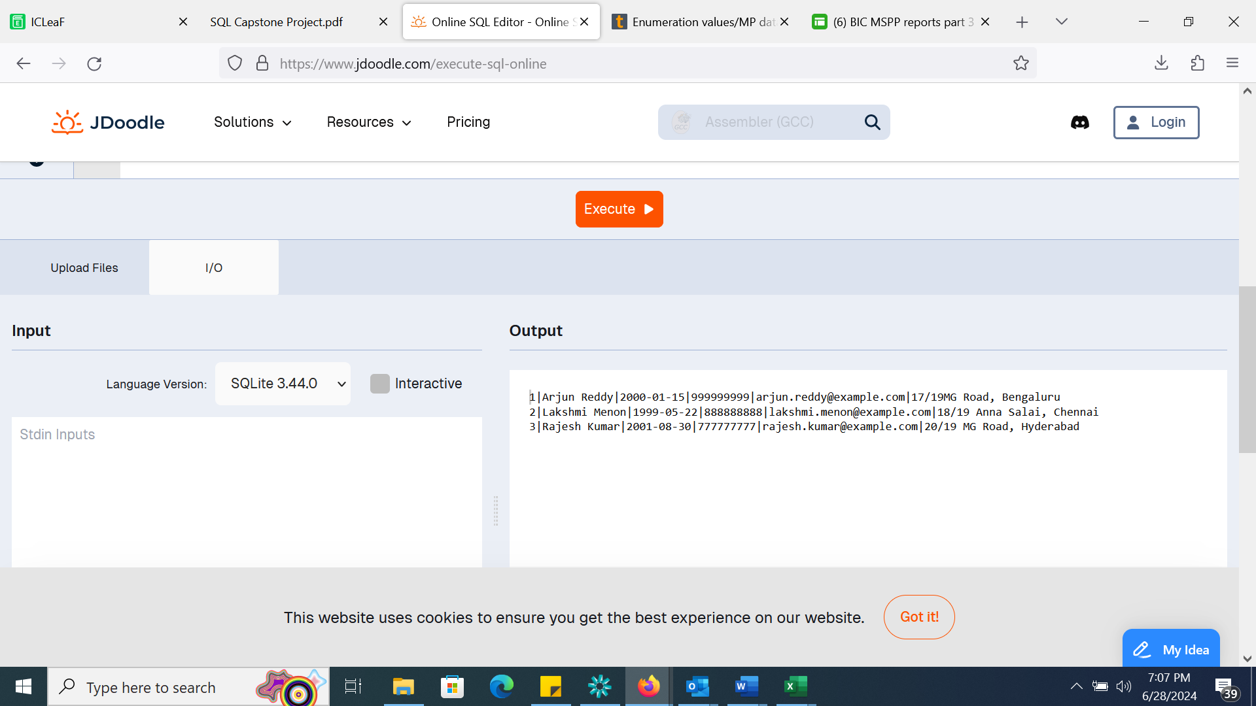

**CourseInfo**

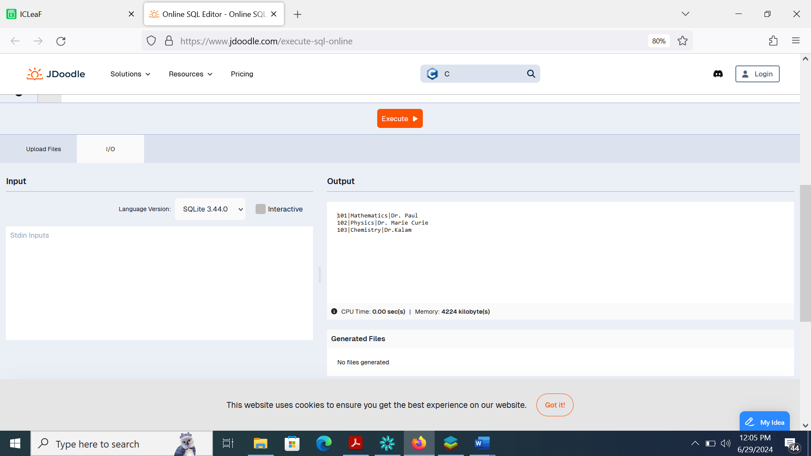

**Enrollment Info**

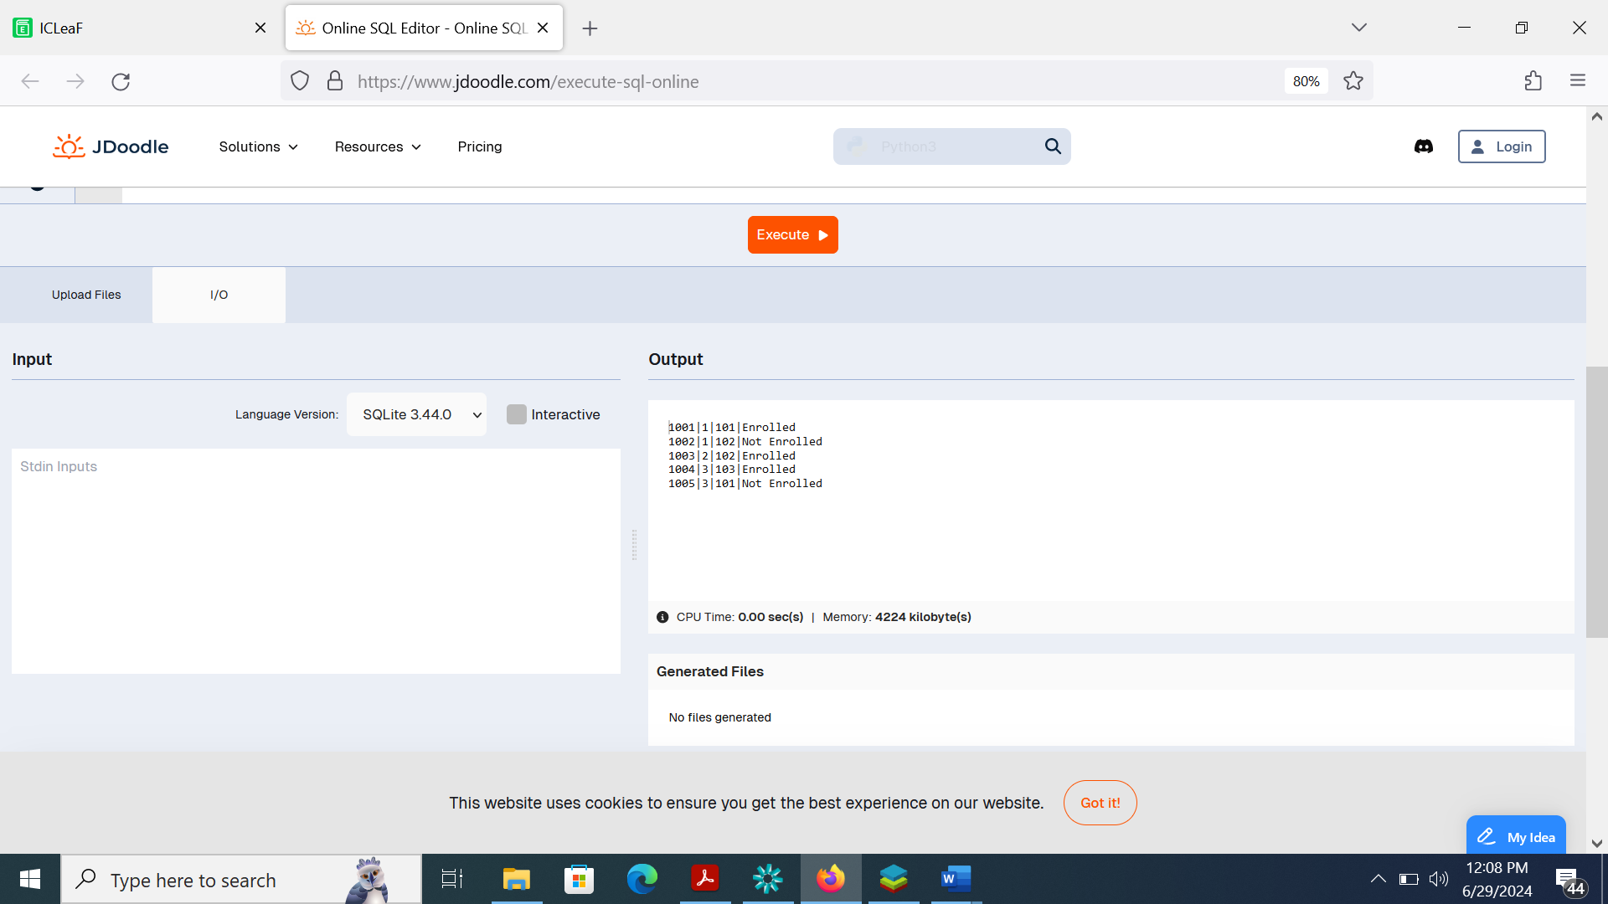

**3) Data retrieval**

a) Retrieve student details, such as student name, contact information, and enrollment status

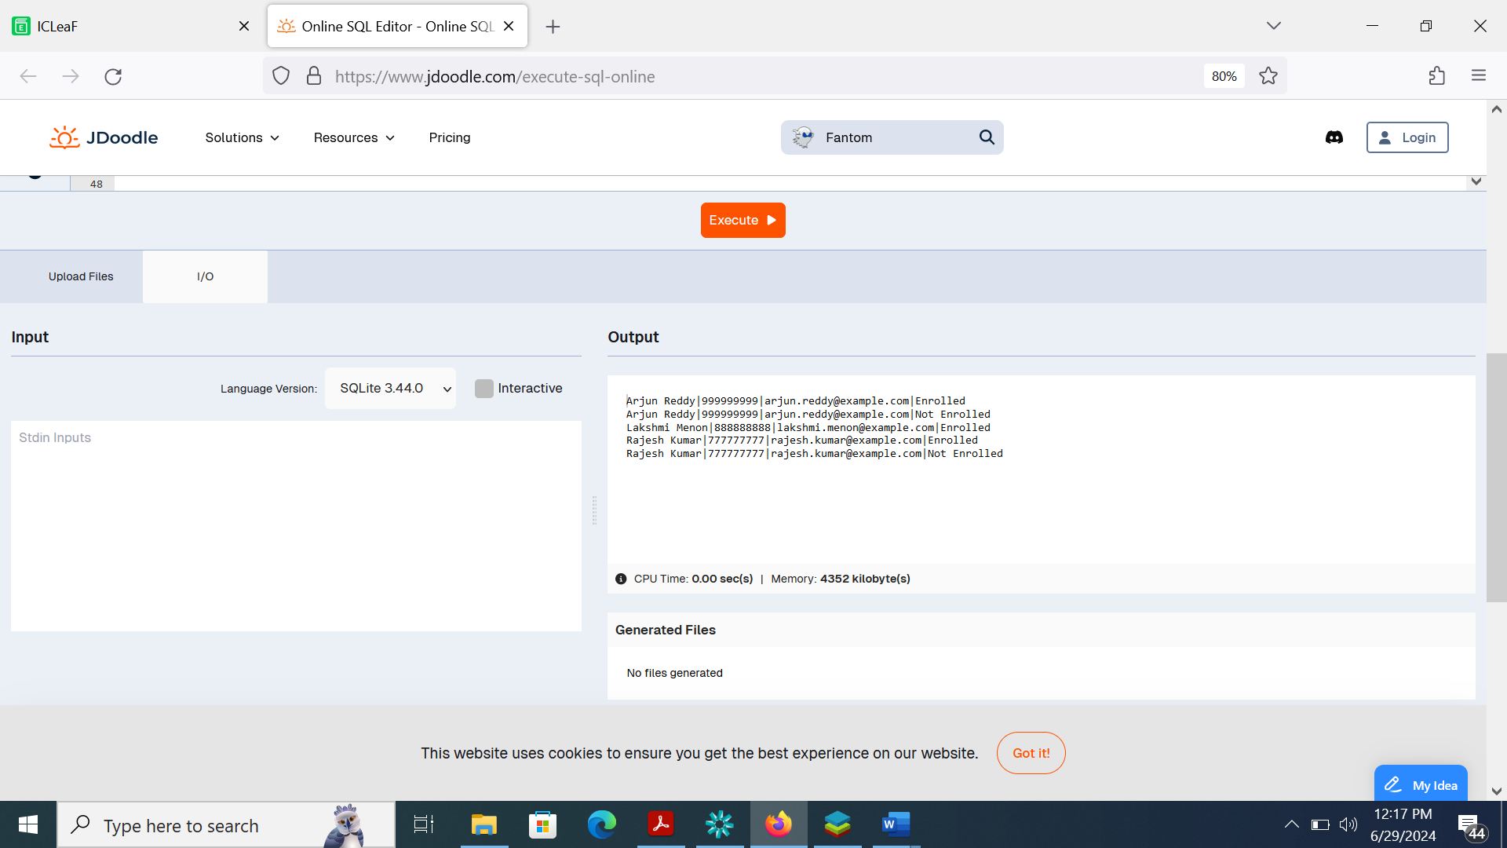

b) Retrieve a list of courses in which a specific student is enrolled

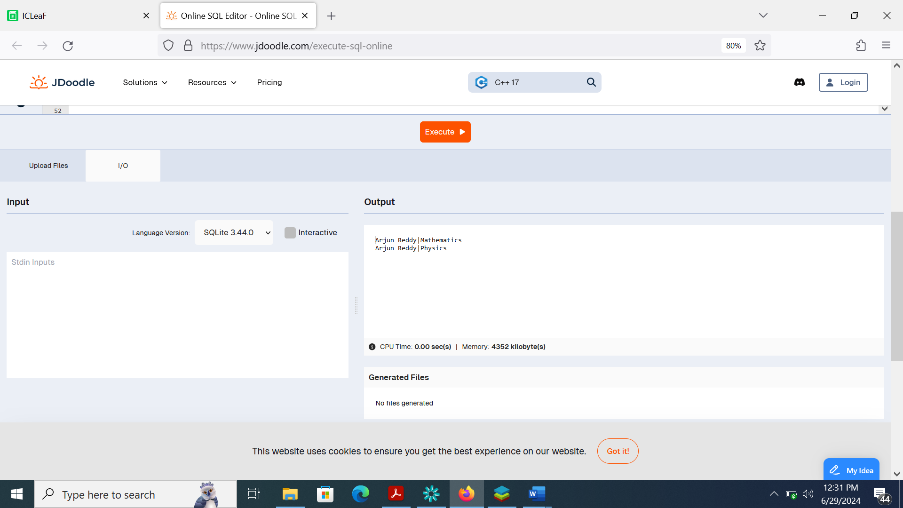

C) Retrieve course information, including course name and instructor information

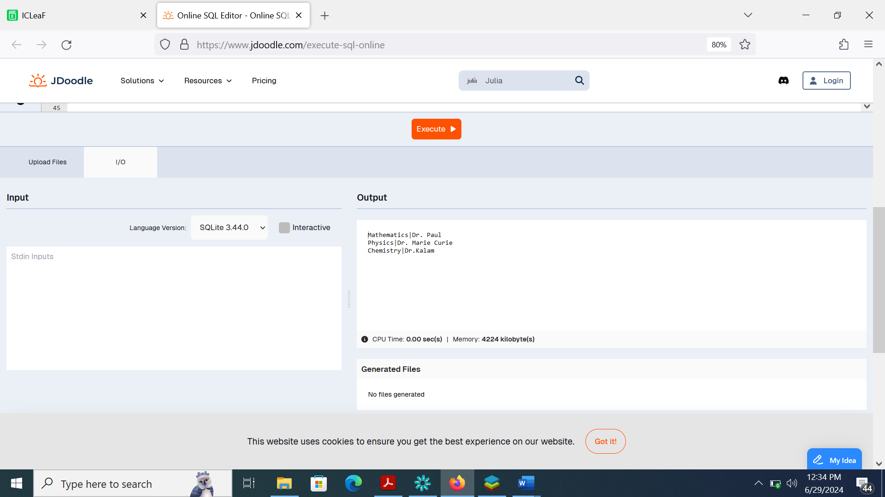

d) Retrieve course information for a specific course

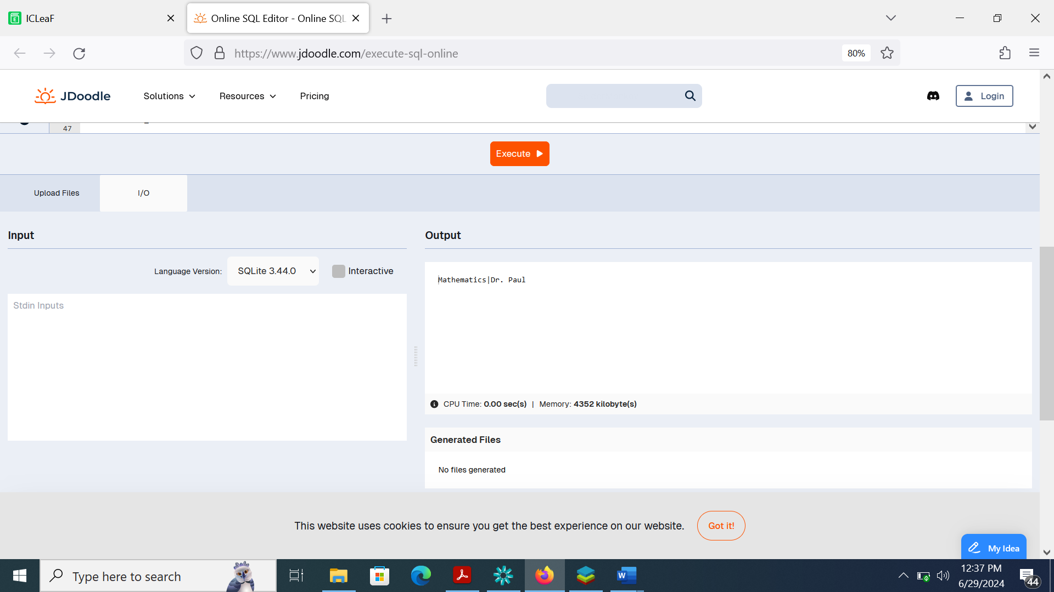

e) Retrieve course information for multiple courses

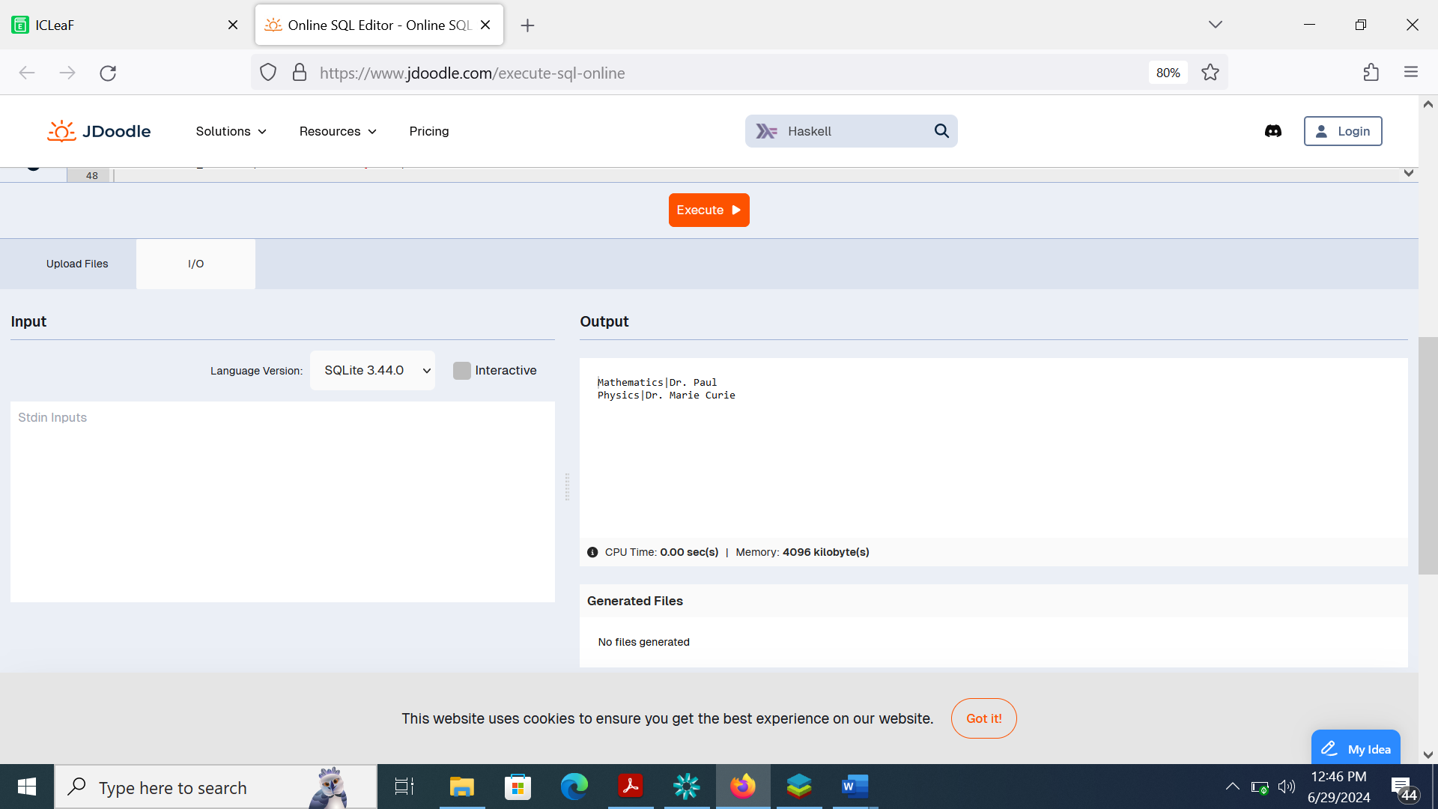

4)

a) Write a query to retrieve the number of students enrolled in each course

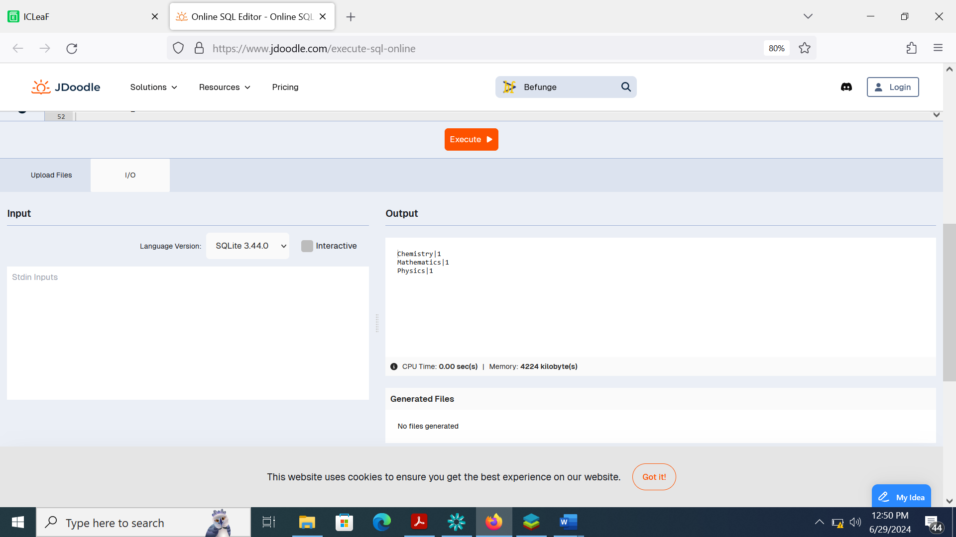

b) Write a query to retrieve the list of students enrolled in a specific course

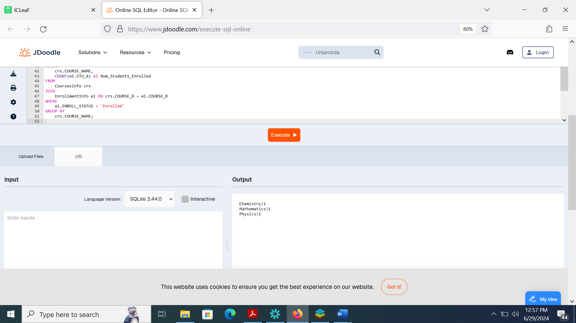

C) Write a query to retrieve the count of enrolled students for each instructor.

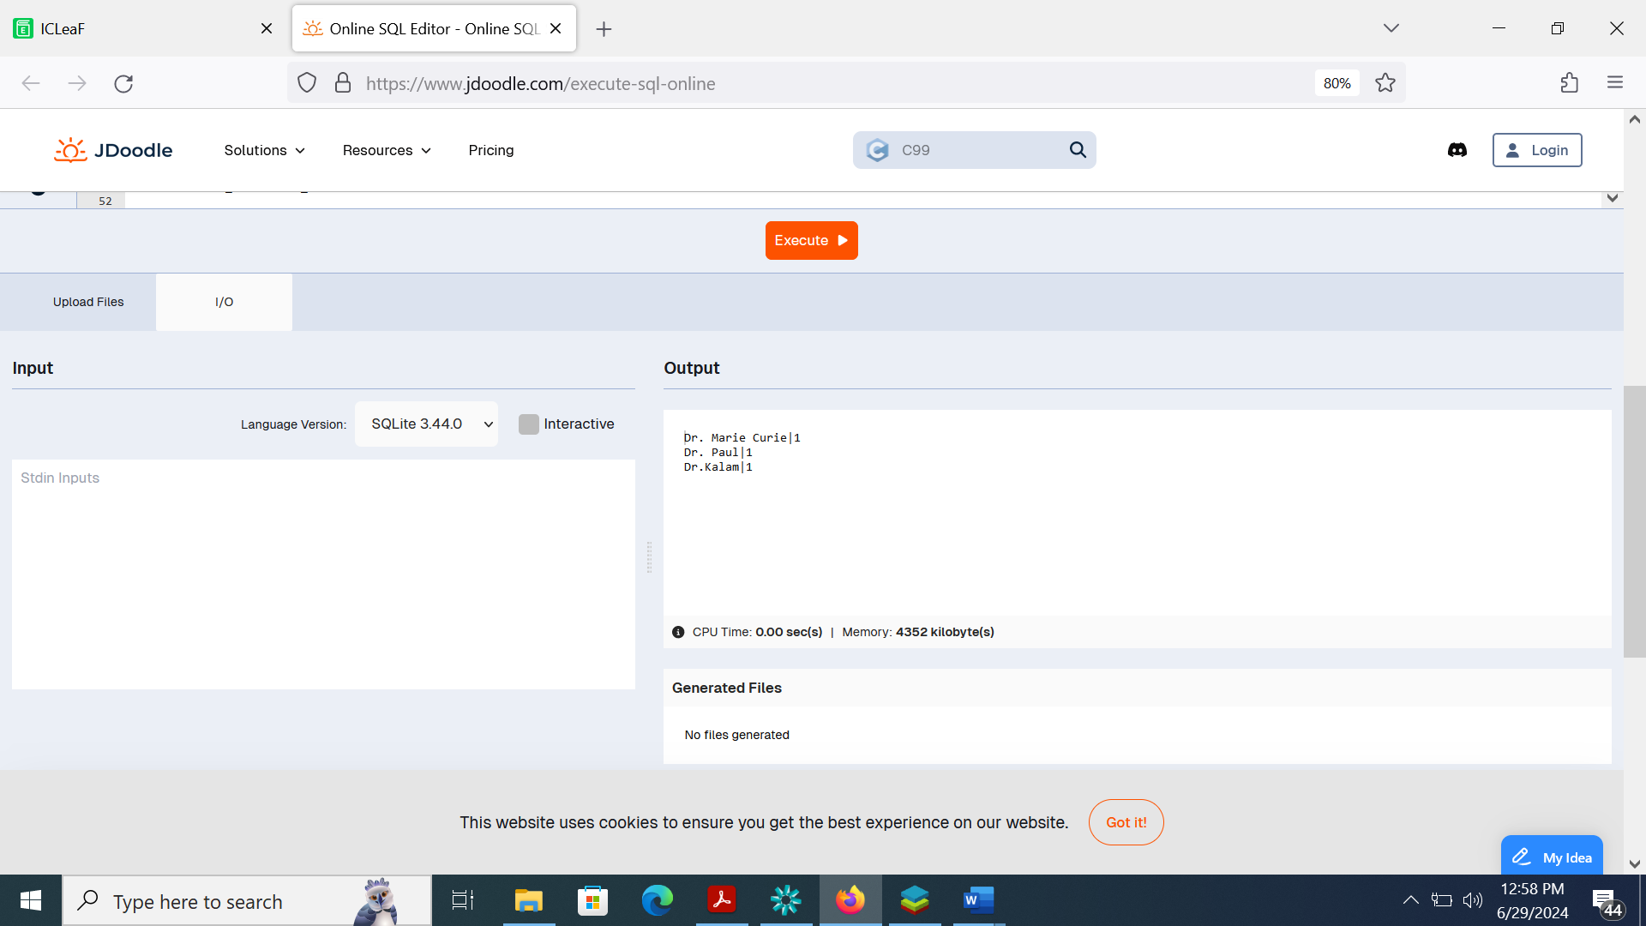

d) Write a query to retrieve the list of students who are enrolled in multiple courses

Output is Blank because there are no students enrolled in multiple courses

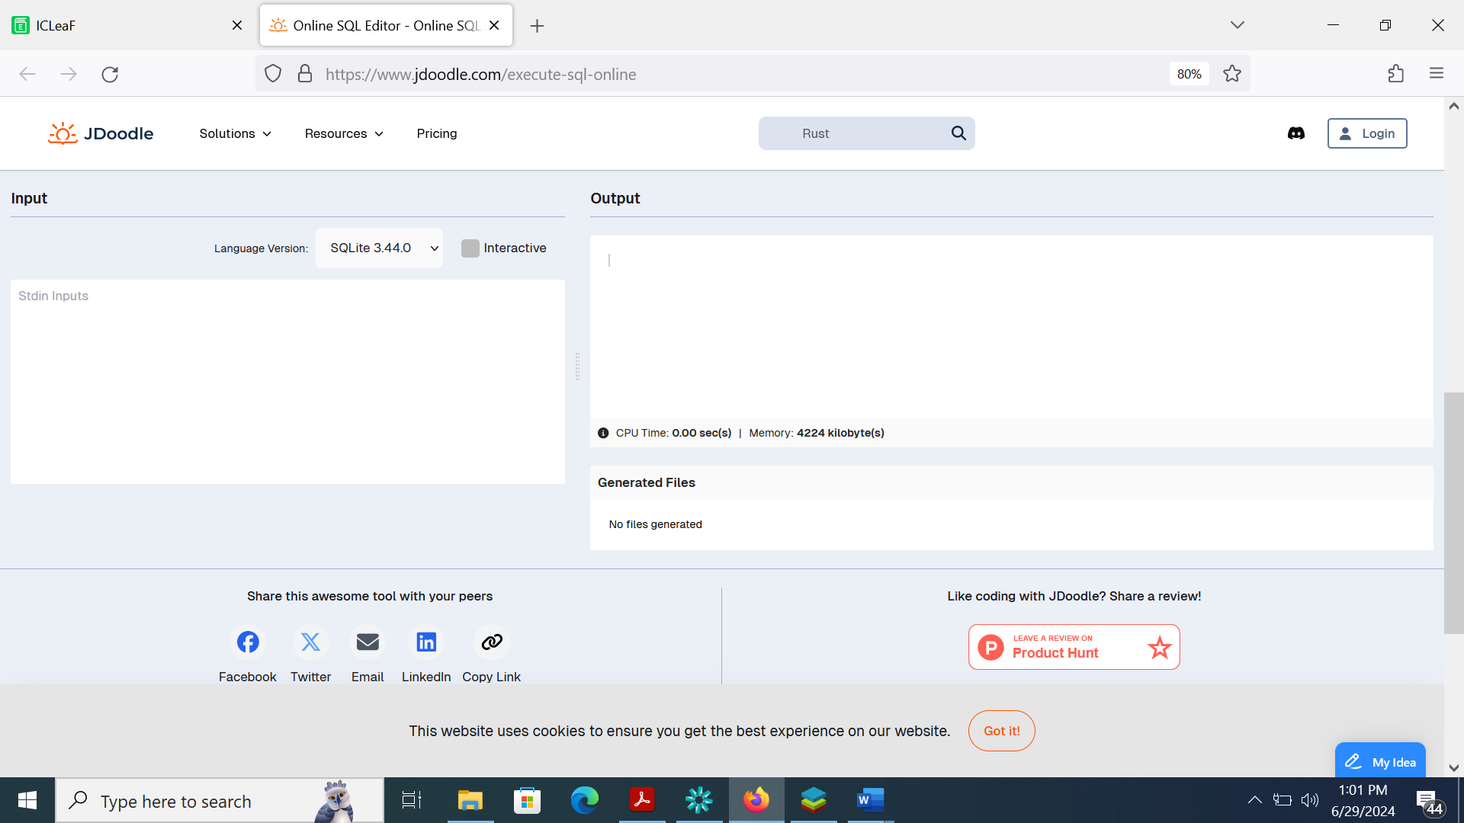

e) Query to retrieve the courses that have the highest number of enrolled students (arranged from highest to lowest)

There are no courses with more than one student enrolled and hence all three are listed with 1

